Wakefield’s SEND Local Offer Annual Report 2020-2021

Contents

Introduction to the Local Offer

Contact Details

Summary of Performance – website

Summary of Performance – newsletter

Summary of Performance – Facebook

Developments and Progress

You Said We Did

Audits

Future Developments

10.Glossary

Introduction to the Local Offer

The Special Educational Needs and / or Disabilities Local Offer is a legal requirement. It tells you things and helps children and young people aged 0-25.

Every Local Authority must give what help they expect to be available in their local area.

Lots of different people contribute to the Local Offer. These can be from education, health care, social care or be parents or young people.

You can find out more details about the Local Offer on the website.

The Local Offer service is provided on behalf of Wakefield Council by Wakefield Early Support, Advice Information Liaison service (WESAIL) Barnardo’s.

This report is an overview of the Local Offer from 1st April 2020 – 31st March 2021.

In Wakefield, the Local Offer Lead is Usha Gough. She helps to put the information that goes on the website, Facebook and in the newsletter. She works part time and started in June 2020.

Before this there were a few months when there was no Local Offer Lead. However, the WESAIL service ensured the Local Offer website was updated as and when needed, especially with relevant updates around Coronavirus. A Local Offer Newsletter was also produced and sent out in this time.

Contact details

You can contact the Local Offer by emailing wakefieldlocaloffer@barnardos.org.uk

You can also leave a message on Facebook.

You can ring 01924 304152 or 07523943888

You can write to Room 249, Castleford Civic Centre, Ferrybridge Road, Castleford, WF10 4JH.

Developments and Progress

These are the things that we have improved this year:

- Rolling programme of updates in place for the website
- Use of photosymbols to enable ease of use
- Beginning to develop easy read information
- Variety of topics and signposting on Facebook and in Newsletter
- Addition of metatags (search words) and logos to allow information to be found more easily
- Gaining and using feedback to improve the Local Offer
- Participation in regional forums to share best practice

Summary of Performance – website

The Local Offer website has had 36,821 visits from April 2020 to March 2021.

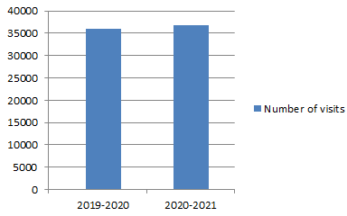

The number of pages viewed this year was 96,008.

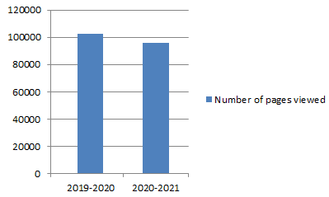

The number of new users on the website was 27,311.

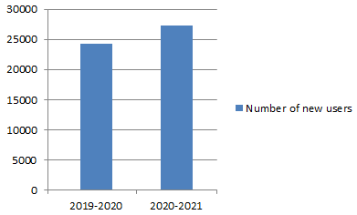

The most popular searches on the website are:
- Educational Health Care Plans (EHCPs)
- Short Breaks
- Information Network
- Autism
- Max Card
- Wakefield Early Support Advice Information Liaison Service (WESAIL)
- Dyslexia

The most viewed pages were:
- Homepage
- Search page
- EHCP
- WESAIL
- Children First Hubs

What have people said about the website?

“There is so much info there. I navigated with C in mind and found relevant info for all the areas he needs support for.”

“Common Concerns section is a good idea.”

“It was straightforward, easy to fill in.”

“Fantastic website and easy to use.”

“Easy to navigate. Page looks fine. All information I needed was here.”

“Brilliant website thank you.”

“This is all amazing- it is so reassuring to know this [information] is available to us.”

The Local Offer website also has a contact button on every page.

This allows users to contact the Local Offer to ask any questions they have or for support.

What have people said about support via the Contact Us button?

“Thanks for your reply, I really appreciate your help.”

“Been such a big help am very grateful thank you so much.”

Summary of Performance – newsletter

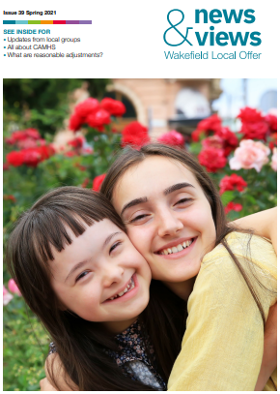

The Local Offer newsletter is called News & Views. It goes out three times a year. It has information on services, support, conditions, advice and things to do.

Due to the Covid pandemic, the Summer 2020 newsletter was not sent out as a hard copy. It was emailed to those registered on the Information Network and was put on the Local Offer website.

The Autumn 2020 and Spring 2021 newsletters were sent out both through the post and via email. It is also signposted on Facebook and put on the Local Offer website.

There are around 1,000 families that receive the newsletter in this way. The newsletter is also sent out to professionals, is signposted on our Facebook page and is available to download on the Local Offer website.

Each newsletter has articles on different ages groups and topics as requested by users to meet their needs.

The feedback from surveys on the newsletter has been very positive, with the majority of people saying they find the articles useful or interesting.

What have people said about the newsletter?

“Your excellent summer newsletter must be a great asset for the community you serve”

“Thank you for sharing this. The breath of articles is really inspiring and it will be very useful for so many different stakeholders.”

“I have just received and really enjoyed reading your informative local offer newsletter.”

“Thanks so much for sending this through and for letting us be included - it looks great!”

This graph shows what people would like to see in future newsletters.
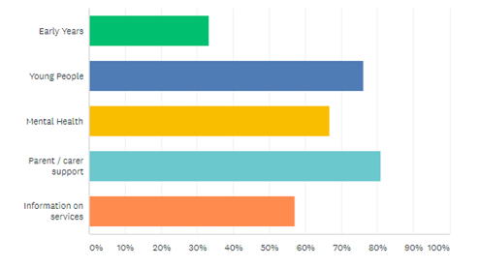

Summary of Performance – social media

The Local Offer Facebook page went from 883 to 996 likes this year
The number of page followers grew from 901 to 1,019 this year.

The most popular posts have been:
- Help at the Hubs
- CAMHS
- New Barnardo’s SENDIASS website
- Y6 transition booklet
- Free e-book on bubbles
- Government guidance on EHCPS
- Complex Care needs teams
- SENART contact

This graph shows the reach of the Facebook page for the year April 2020 – March 2021:
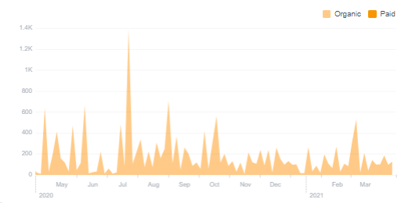

The Local Offer Facebook page continues to post a wide range of topics. These can be about support, information or events.

What have people said about Facebook?

“Brill any help would be great.”

“Thank you so much.”

You Said We Did

You Said We Did is where we respond to feedback about the Local Offer. Feedback is where you tell us what you think.

You can find out how we get feedback on the Local Offer website.

You Said is what you think.
We Did is what we are doing about it.

You Said | We Did
I haven’t seen the newsletter mentioned anywhere. | We post newsletter updates on our Facebook page.  We will ask other local groups to share these posts.  We will ask other professionals to signpost to our newsletter.
Shorter information is better as it’s more to the point. | We are working on making our newsletter and website easier to read.  We have begun to create ‘Easy Read’ documents for the Local Offer.  We have begun to include ‘Easy Read’ articles in our newsletter.
It would be good to have a local dyslexia support group. | We will contact the nearest dyslexia support groups through the British Dyslexia Association. We will invite them to join the Local Offer.
Why is the Local Offer all about autism and not different conditions? | We will publish the different services and conditions we have supported at the end of each month on Facebook.  We will continue to have a range of articles in the newsletter.  We will continue to provide support and signposting for autism as it is the most requested by parents and professionals.  We welcome any suggestions for different services and conditions.
We would like information on supported living and moving on to adulthood. | We have created a new Preparation for Adulthood section on the Local Offer website.  We are continuing to make this more accessible.
We would like information on school exclusions. | We have put some information on the Local Offer.  We will add more information soon.
The Autism Spectrum Disorder (ASD) pathway is not up to date | We are working with Mid Yorkshire Hospitals to update the ASD pathway.  The new referral form is on the Local Offer website.
We would like a list of alternative provisions for post-16. | We are updating the Local Offer to make this information easier to find.

Audits

An audit is where another service, professional or group look at some information and say what is good about it. They can also say what needs improving.

They might use a survey or report to help them do the audit.

We have conducted mystery shops to help audit the Local Offer.

A mystery shop is where someone is asked to find specific information. They then say how easy or hard it was to do that.

The mystery shoppers we asked felt that the information on the assessment journey process was clear and easy to read. However, they also felt that the information on Post-16 options was not accessible for young people themselves.

Wakefield Parent Carer Forum (WPCF) ran a survey in November which was mostly positive.

This graph shows the survey results.
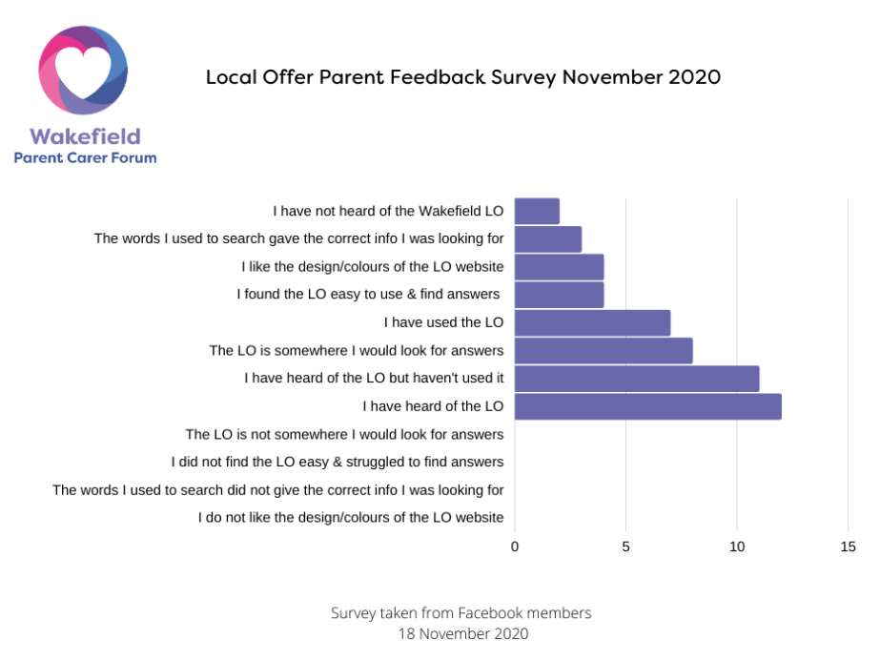

We were also audited by another Local Authority in November 2020.

The main positive things they found were:

- Assessment and Education Health Care Plan information is clear
- In-area education easy to find
- Personal budget information easy to find
- Information Advice Services information is comprehensive
- Preparation for Adulthood section is full with lots of information and links
- The website has comprehensive information

The main things to develop are:

- Ensure health information on continuing or adult care is easy to find
- Further information on transitions / transfer between phases of education
- Make it clear what the Local Authority expects educational settings to offer
- Make it clear how other people have been involved in developing the Local Offer

Future Developments

The Local Offer has been highlighted as one of the key priorities for Wakefield Council in the SEND Strategy for 2020-2024. The aims are to:

“…reduce gaps in services by strengthening joint commissioning. Improve communication with key partners, children, young people and their families and ensure clarity of the support available.”

To build on the positives from this year the SEND Local Offer will be:

Even better if… We increase our joint working with children, young people, parents and carers. This is also called coproduction. We will do this by working with Kid Squad (the SEND Young People’s Advisory Group), Wakefield Parent Carer Forum and Wakefield Awareness Support Project. We will also work with our Local Offer Champions.

Even better if… Services are encouraged to keep their information up to date. We will do this through our Local Offer Champions and Local Offer Together meetings.

Even better if… We develop more easy read and accessible information on the Local Offer. We will do this by working with a newly-appointed Workshop and Accessibilities Coordinator and attending accessibility training. We will also use audits completed by parents, carers, children, young people, professionals and Local Offer Together meetings.

Glossary of abbreviations and acronyms

ASD – Autism Spectrum Disorder
CAMHS – Children and Adolescent Mental Health Service
EHCP – Educational Health Care Plan
IN – Information Network
LO – Local Offer
SENART – Special Educational Needs Assessment Review Team
SEND – Special Educational Needs and / or Disability
SENDIASS – Special Educational Needs and / or Disabilities Information Advice Support Services
WASP – Wakefield Awareness Support Project
WESAIL – Wakefield Early Support, Advice and Information Liaison Service
WPCF – Wakefield Parent Carer Forum

