Dear Parent/Carer,
During this school year, Children, Young People and Family Services in partnership with Hull Parents Forum, Special Schools and Passenger Transport Service together have implemented some changes to home to school transport; so you can have the confidence your child is being transported safely whilst in our care travelling home and from school. This information is to inform you what has been happening and what is still to do.

Passenger Transport Drivers
All drivers receive Safeguarding Training whether they are a licenced taxi driver or a passenger transport driver; passenger transport drivers have all been issued with an ID badge which they should be displaying at all times whilst transporting children. If your child’s driver is not displaying their ID badge or if you ask to see it and they cannot show you please contact transport on 01482 612808 immediately.
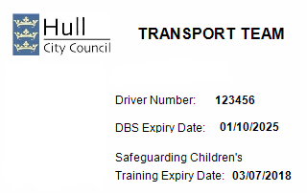
Happy or Not
Children who are transported to Ganton Primary School were asked to let us know:
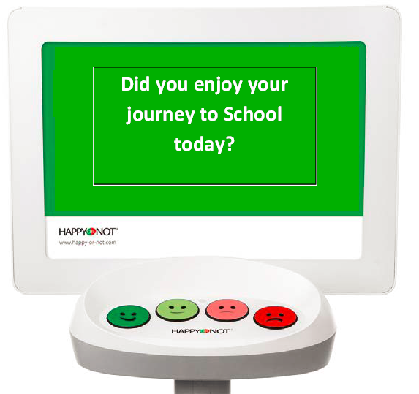
Choosing one of the faces this is what children said:
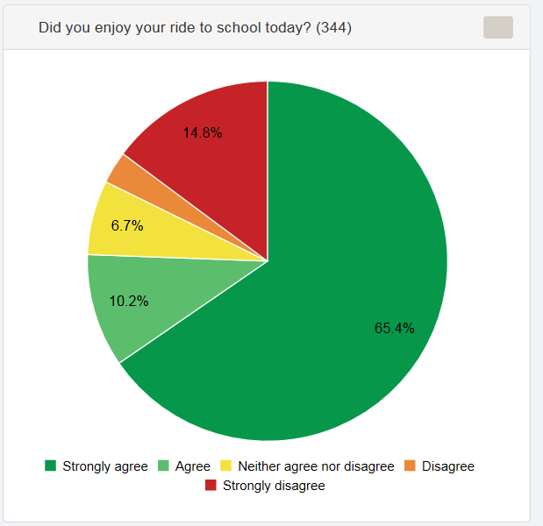
Your child will have the opportunity with the support from school staff to give feedback as the device will be placed in all our special schools for a period of time this will assist us to focus on certain journeys if a child say they are unhappy.

Medical Care Need Plans
A plan is in place for parents to provide detailed information relating to their child’s medical care needs, behaviours, likes and dislikes; this is so drivers and passenger assistants have all the information they need to ensure they are aware of your child’s medical needs should an incident happen. If you have not yet received a form to complete please telephone Fiona Bell on 616363 so a form can be sent out to you.

Annual Transport Survey
You will shortly be receiving a transport survey for you to provide your feedback and comments.
Personal Transport Budgets
During this school year a number of parents volunteered to pilot a Personal Transport Budget. This is an allowance paid monthly so you can organise your child transport arrangements. The allowance depends on the distance between home to school. One parent said: ‘the transport budget has made such a massive difference to my son. School life has continued since receiving the personal budget without too many challenging episodes, my sons anxiety levels have been kept at a level of been able to control a situation that could have otherwise super difficult. Overall the transport budget has made everyday life a lot less stressful and a lot better to deal with on a daily basis. Thank you so so much.’
If you would like more information please email: Fiona.bell@hullcc.gov.uk

Independent Travel Training
To assist and support young people with the skills, knowledge and confidence in preparation for adulthood; an independent travel trainer has been recruited by Children and Young People Services. If you feel with dedicated one to one support your child could travel independently please contact Lee Tether on 615203.

Journey Times
Department of Education recommended journey times; 45 minutes primary age children and 75 minutes secondary. Work is underway to try to minimise the time it takes a child to get to and from school. Unfortunately, it will not always be possible to transport within these times; however, we are going to try our best; if your child is picked up too early or dropped off later than you would expect please contact Fiona Bell on 616363.

Transport Passport
From the information you are providing; your child’s likes, dislikes and behaviours will be generated in to a Transport Passport, each child will have one. The driver and personal assistant will have a copy too; this will help not only your child if there are driver/personal assistant changes also give you the opportunity to update the information we have recorded.

Transport Review
Each child will in the future have an annual transport review. This is so we can ensure the correct transport arrangements are in place to meet your child’s needs along with updating your child’s information.

Hull Local Offer Website (http://hull.mylocaloffer.org )
Hopefully you have accessed the Hull Local Offer website; a lot of useful information is available on here including transport:
- Home to school transport 5-15 years
- Home to school transport Post 16-19 years
- Useful information and resources
- Transport policies and guidelines
- Public transport
- Personal Transport budgets

September Transport Arrangements
We are currently preparing for the next school year. You will in good time before school starts back again receive your child’s transport arrangements; these will include:
- Pick up and drop off times which have been checked by the driver so they are accurate
- Transport company details transporting your child
- The name and telephone number of the driver (if there is no personal assistant)
- The name and telephone number of the personal assistant

Home to School Transport Logo
Members of Children’s Disability LAFSS art group have been designing a home to school transport logo, they are in the final stages and the design is being taken to groups of children in schools so they can decide if they like it. The design will be included on all information you receive as well as displayed on the buses.

