Children, Young People and Family Services
Transport Service ID Badges

As from September 2018, all drivers who transport children and young people will be displaying a Transport Team ID badge. The Transport ID badge is issued by Passenger Transport Service the purpose is to notify parents/carers, school and safeguarding staff the driver has been approved by Hull City Council they have a current Enhanced Disclosure and Barring Certificate (DBS) and have also attended Safeguarding training; the badge also includes expiry dates.
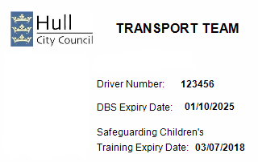

Drivers Picture

To safeguard our children and young people when they are being transported please ask the driver to present their Transport Team ID badge to you checking the expiry dates.
If the driver does not present you with a Transport Team ID badge or the dates have expired do not place the child in the vehicle, immediately contact Passenger Transport Team on telephone 01482 XXXXX who will organise you a replacement vehicle with an approved driver.

